

Founder bio
Leo Garcia-Curtis
Founder, Waboom AI
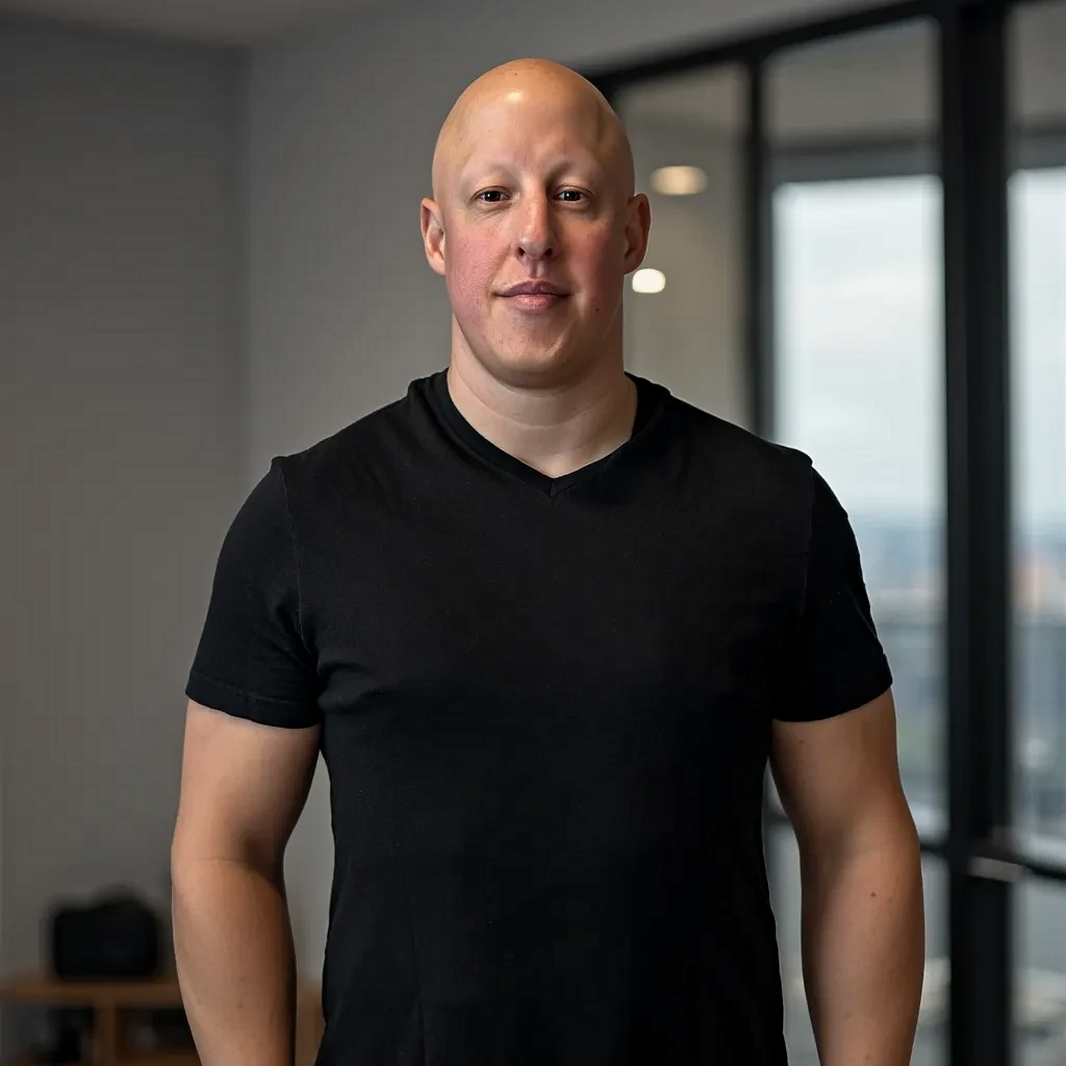 | Leo Garcia-Curtis is the founder of Waboom AI, an AI consultancy and technology company. Waboom helps leading organisations across APAC turn artificial intelligence into practical business advantage.  He has more than 20 years in business, ecommerce and technology. He is also behind New Zealand's largest AI telephony service.  His focus is people and process first, technology second.
Which title to use
Where | Title
Default. Cards, email, proposals, contracts, website. | Founder, Waboom AI
Speaking. Programmes, panels, slides, podcasts. | Founder and AI Strategist, Waboom AI
LinkedIn headline. | Founder, Waboom AI. Helping APAC leaders turn AI into commercial advantage. Less Busy. More Life.
Avoid "AI Evangelist", "Thought Leader" and "AI Expert". They cost credibility with the executives Waboom sells to.

Use this one by default
Full bio, about 180 words
Leo Garcia-Curtis is the founder of Waboom AI, an AI consultancy and technology company. Waboom helps leading organisations across APAC turn artificial intelligence into practical business advantage.
Leo has more than 20 years in business, ecommerce and technology. He has led premier Shopify Plus agencies and helped global brands grow through ecommerce, omnichannel marketing and digital strategy.
Today he works alongside executives. He finds the gaps and the bottlenecks that hold a business back. He uncovers the opportunities others miss. Then he shows the team where AI creates the greatest commercial impact.
His focus is not adopting more technology. It is helping organisations educate their people and rethink how the work gets done. AI is the tool that unlocks growth, builds capability and makes the business more scalable.
Through Waboom AI, Leo is also behind New Zealand's largest AI telephony service. It brings AI into real sales, service and customer conversations at scale.
The goal is simple. Bigger opportunities. Smarter businesses. More capable teams. Less Busy. More Life.
Medium bio, about 100 words
Panel programmes, partner sites, podcast show notes.
Leo Garcia-Curtis is the founder of Waboom AI, an AI consultancy and technology company working with leading organisations across APAC.
He has more than 20 years in business, ecommerce and technology, including leadership of premier Shopify Plus agencies and growth work for global brands.
Today Leo works alongside executives to find the bottlenecks that hold a business back, and to show where AI creates real commercial impact. His focus is people and process first, technology second.
He is also behind New Zealand's largest AI telephony service.
Less Busy. More Life.

Shorter versions
Short bio, about 50 words
Speaker one liners, LinkedIn About opener, email introductions.
Leo Garcia-Curtis is the founder of Waboom AI. He has more than 20 years in business, ecommerce and technology. He works alongside executives across APAC to find where AI creates real commercial impact, and he is behind New Zealand's largest AI telephony service.
One line, about 25 words
Under a photo, on a slide, in a byline.
Leo Garcia-Curtis is the founder of Waboom AI. He helps APAC executives turn artificial intelligence into practical commercial advantage.
Shorter again, for a slide:
Founder, Waboom AI. Twenty years in business, ecommerce and technology.
Speaker introduction, read aloud
Written for the ear, not the page. About 30 seconds.
Our next speaker has spent more than twenty years building businesses in ecommerce and technology. He has led premier Shopify Plus agencies and helped global brands grow. Today he runs Waboom AI, and he works with executives across Australia and New Zealand on one question. Where does AI actually make money in your business? He is also behind New Zealand's largest AI telephony service. Please welcome the founder of Waboom AI, Leo Garcia-Curtis.

Email signature
Leo Garcia-Curtis
Founder, Waboom AI
leo@waboom.ai | waboom.ai

Less Busy, More Life.
The comma form of the tagline is used here because it has to hold one line.
Photograph
The portrait on page one is the approved image. Print and web files are supplied with this document. Do not crop above the shoulders, do not recolour, and do not run it through an AI upscaler.
Print file: leo-portrait-restored-2048.png. 2048 x 2048 at 300 dpi, which prints clean up to 173mm wide.
Web file: leo-portrait-restored-1024.png.

